 CHEMICAL ENGINEERING TRANSACTIONS  VOL. xxx, 2026 | A publication of  
The Italian Association
of Chemical Engineering
Online at www.cetjournal.it

Guest Editors: Flavio Manenti, Botir Usmonov, Alessandro Di Pretoro
Copyright © 2026, AIDIC Servizi S.r.l.
ISBN 979-12-81206-xx-x; ISSN 2283-9216

KINETIC ATR-FTIR ANALYSIS OF THE MORPHOLINE–SODIUM MONOCHLOROACETATE REACTION
Mamatkulova Sadoqat Olimovnaª*, Aytura Sitdikovna Maksumovaª
ªDepartment of Organic Synthesis Technology, The Tashkent Institute of Chemical Technology, Tashkent, Uzbekistan
sadoqatmamatkulova@gmail.com
Organic nitrogen-containing compounds, including morpholine derivatives, are widely used in chemistry, pharmaceuticals, and technological processes. Studying the kinetic laws of the reactions for obtaining these morpholine derivatives is crucial for determining the thermodynamic parameters of the process under optimal conditions. Real-time monitoring of the reaction and determination of kinetic parameters were conducted using ATR-FTIR spectroscopy. The experiments were performed at 60, 70, and 80°C under constant stirring conditions. Changes in the absorption zone within the range of 1580–1670 cm⁻¹ were observed during the reaction, and this zone was selected as the primary kinetic region. The conversion degree and the apparent kinetic parameters were evaluated using an apparent first-order kinetic model based on the relationship ln(1−X)=−kt. The rate constants at 60°C, 70°C, and 80°C were 0.01653 min⁻¹, 0.01729 min⁻¹, and 0.01752 min⁻¹, respectively. According to the Arrhenius equation, the apparent activation energy was estimated to be 2.86 kJ/mol. The results demonstrate that ATR-FTIR spectroscopy is an effective method for monitoring this reaction and assessing kinetic parameters.
  - Introduction
Morpholine and its derivatives play a significant role in organic synthesis, pharmaceuticals, and the chemistry of functional materials. Smith (2020) stated that morpholine, as a nitrogen-containing heterocyclic amine, exhibits nucleophilic properties and participates in N-substitution reactions. Elangovan et al. (2016) reported that selective N-alkylation of amines is an effective route for obtaining practically important nitrogen-containing compounds. The reaction between morpholine and sodium monochloroacetate is expected to proceed via a bimolecular nucleophilic substitution (SN2) mechanism. Phan et al. (2009) showed that the SN1/SN2 pathway depends on nucleophilicity, substrate structure, and reaction environment. Hamlin et al. (2018) reported that SN2 reactivity is governed by the combined effects of the nucleophile, leaving group, substituents, and solvent. Tang et al. (2024) further demonstrated that external factors, such as oriented electric fields, can significantly influence SN2 reaction rates. A similar approach was employed by Mamatkulova and Maksumova (2026), who demonstrated through ATR-FTIR monitoring that the conversion and rate constants of the SN2 reaction could be evaluated in the system of piperidine and chloroacetic acid.
Sodium monochloroacetate is an important functional substrate in organic synthesis due to its simultaneous presence of both carboxylate and chloromethyl fragments. Ivanov et al. (2025) studied the spectral properties of compounds containing the monochloroacetate group and concluded that the vibrations specific to the COO⁻ and C–Cl groups can be clearly observed in the infrared spectrum. This data provides a spectral basis for monitoring the reaction between morpholine and sodium monochloroacetate through infrared spectroscopy. ATR-FTIR spectroscopy is a rapid and convenient method for real-time monitoring of chemical reactions. Christie et al. (2024) described ATR-FTIR spectroscopy as an effective tool for in situ process monitoring. Dubé et al. (2004) highlighted its advantages for rapid analysis of reaction mixtures. Trevisan et al. (2008) showed that reaction conversion can be calculated from time-dependent ATR-FTIR spectral changes. Husár et al. (2021) confirmed the reliability of FTIR-based methods for process monitoring and product quality control. Husar and Ait El Maati (2025) demonstrated the applicability of real-time FTIR-ATR monitoring for kinetic studies.
Based on this, this work aims to study the reaction between morpholine and sodium monochloroacetate in the temperature range of 60–80°C using ATR-FTIR, to identify the spectrally sensitive region for the reaction, and to evaluate the primary kinetic laws. The simplified reaction scheme for the process between morpholine and sodium monochloroacetate is shown in Scheme 1.
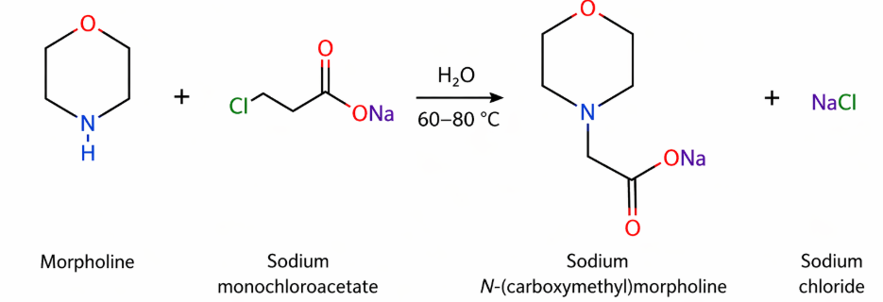
Scheme 1. Reaction of morpholine with sodium monochloroacetate in an aqueous medium (60–80 °C), resulting in the formation of sodium N-(carboxymethyl)morpholine.
In the reaction shown in Scheme 1, the free electron pair of the nitrogen atom in the morpholine molecule attacks the chloromethyl group, forming a new C–N bond, and NaCl is released.
  - Methodology
Morpholine with a purity of at least 99.0% and recrystallized sodium monochloroacetate were used as the primary reagents. Distilled water was used as the solvent. The reaction mixtures were prepared separately for 60, 70, and 80 °C. In each experiment, morpholine and sodium monochloroacetate were taken in a 1:1 molar ratio. The experiments were conducted using a magnetic stirrer (ULAB US-1550D) with heating. Reaction temperatures of 60, 70, and 80 °C were maintained throughout the process. The reaction process was monitored using ATR-FTIR spectroscopy. Spectra were recorded on a Shimadzu IRSpirit spectrometer equipped with a QATR-S single reflection ATR module. After a homogeneous reaction mixture had been obtained, the initial spectrum (t = 0 min) was recorded. After that, ATR-FTIR spectra were recorded every 10 min for 180 min at each temperature. The progress of the reaction was evaluated based on changes in the absorption bands characteristic of the reagents and products. Comparative analysis of the spectra identified the 1580–1670 cm⁻¹ range as the most sensitive spectral region for monitoring the reaction. This region is associated with vibrations of the carboxylate group, allowing for the observation of sodium monochloroacetate consumption and product formation during the reaction. For determining the reaction conversion and kinetic parameters, the absorbance values obtained from ATR-FTIR spectra were used. ATR-FTIR spectroscopy allows for real-time monitoring of reaction mixtures and evaluation of the reaction progress based on spectral signal changes (Dubé et al., 2004). The conductivity values recorded in the infrared spectra were converted to absorbance using the following equation:
$$A=-log\left(\frac{T}{100}\right)$$ | (1)
According to the approach proposed by Trevisan et al. (2008), the reaction conversion was calculated based on the time-dependent change of the selected spectral signal using the following formula:
$$X=\frac{A_{t}-A_{0}}{A_{max}-A_{0}}$$ | (2)
The reaction kinetics were evaluated using an apparent first-order kinetic model based on the conversion values obtained from the ATR-FTIR spectral data. This approach was adopted to describe the overall kinetic behavior of the reaction under the investigated experimental conditions and to compare reaction rates at different temperatures.
$$\ln\left(1-X\right)=-kt$$ | (3)
The effect of temperature on the reaction rate was evaluated using the Arrhenius equation:
$$\ln{k}=lnA-\frac{E_{a}}{RT}$$ | (4)
  - Results and Discussion
The spectral and kinetic properties of the reaction between morpholine and sodium monochloroacetate were analyzed based on ATR-FTIR spectra. Comparative analysis of the spectra identified the most sensitive spectral region with respect to the reaction process, which was then accepted as the basis for further kinetic calculations. When comparing the initial spectrum (t = 0 min) with the spectra after 180 minutes, the main changes were observed in the 1580–1670 cm⁻¹ range. The variation in transmittance values in this region reflected spectral changes related to the carboxylate group in the reaction environment. This range, being sensitive to the carboxylate group, was chosen for kinetic analysis due to the most prominent changes observed in this region.
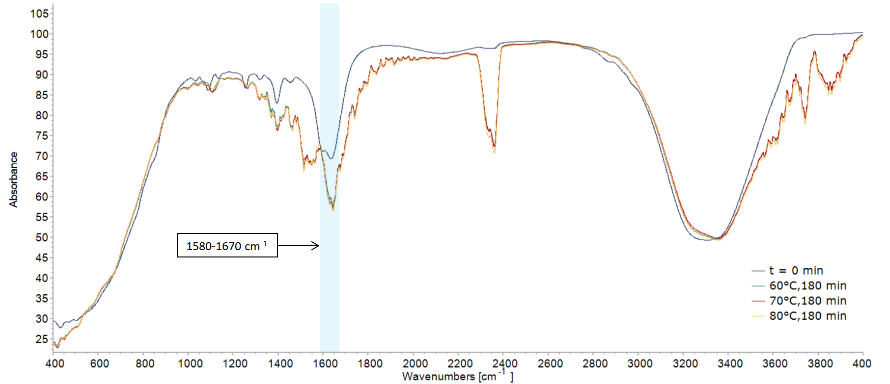
Figure 1: ATR-FTIR spectra for the reaction between morpholine and sodium monochloroacetate: initial state (t = 0 min) and spectra recorded after 180 minutes at 60, 70, and 80°C.
As the temperature increased, the degree of change in the spectral signal within the 1580–1670 cm⁻¹ range also increased. In particular, the spectrum recorded at 80°C showed a higher degree of change compared to the results at 60 and 70°C, indicating that the reaction accelerated with increasing temperature. To more accurately assess the reaction dynamics, the 1580–1670 cm⁻¹ range was analyzed separately with an enlarged view. The consistent change in transmittance values in this region allowed for a clearer representation of the reaction progress.
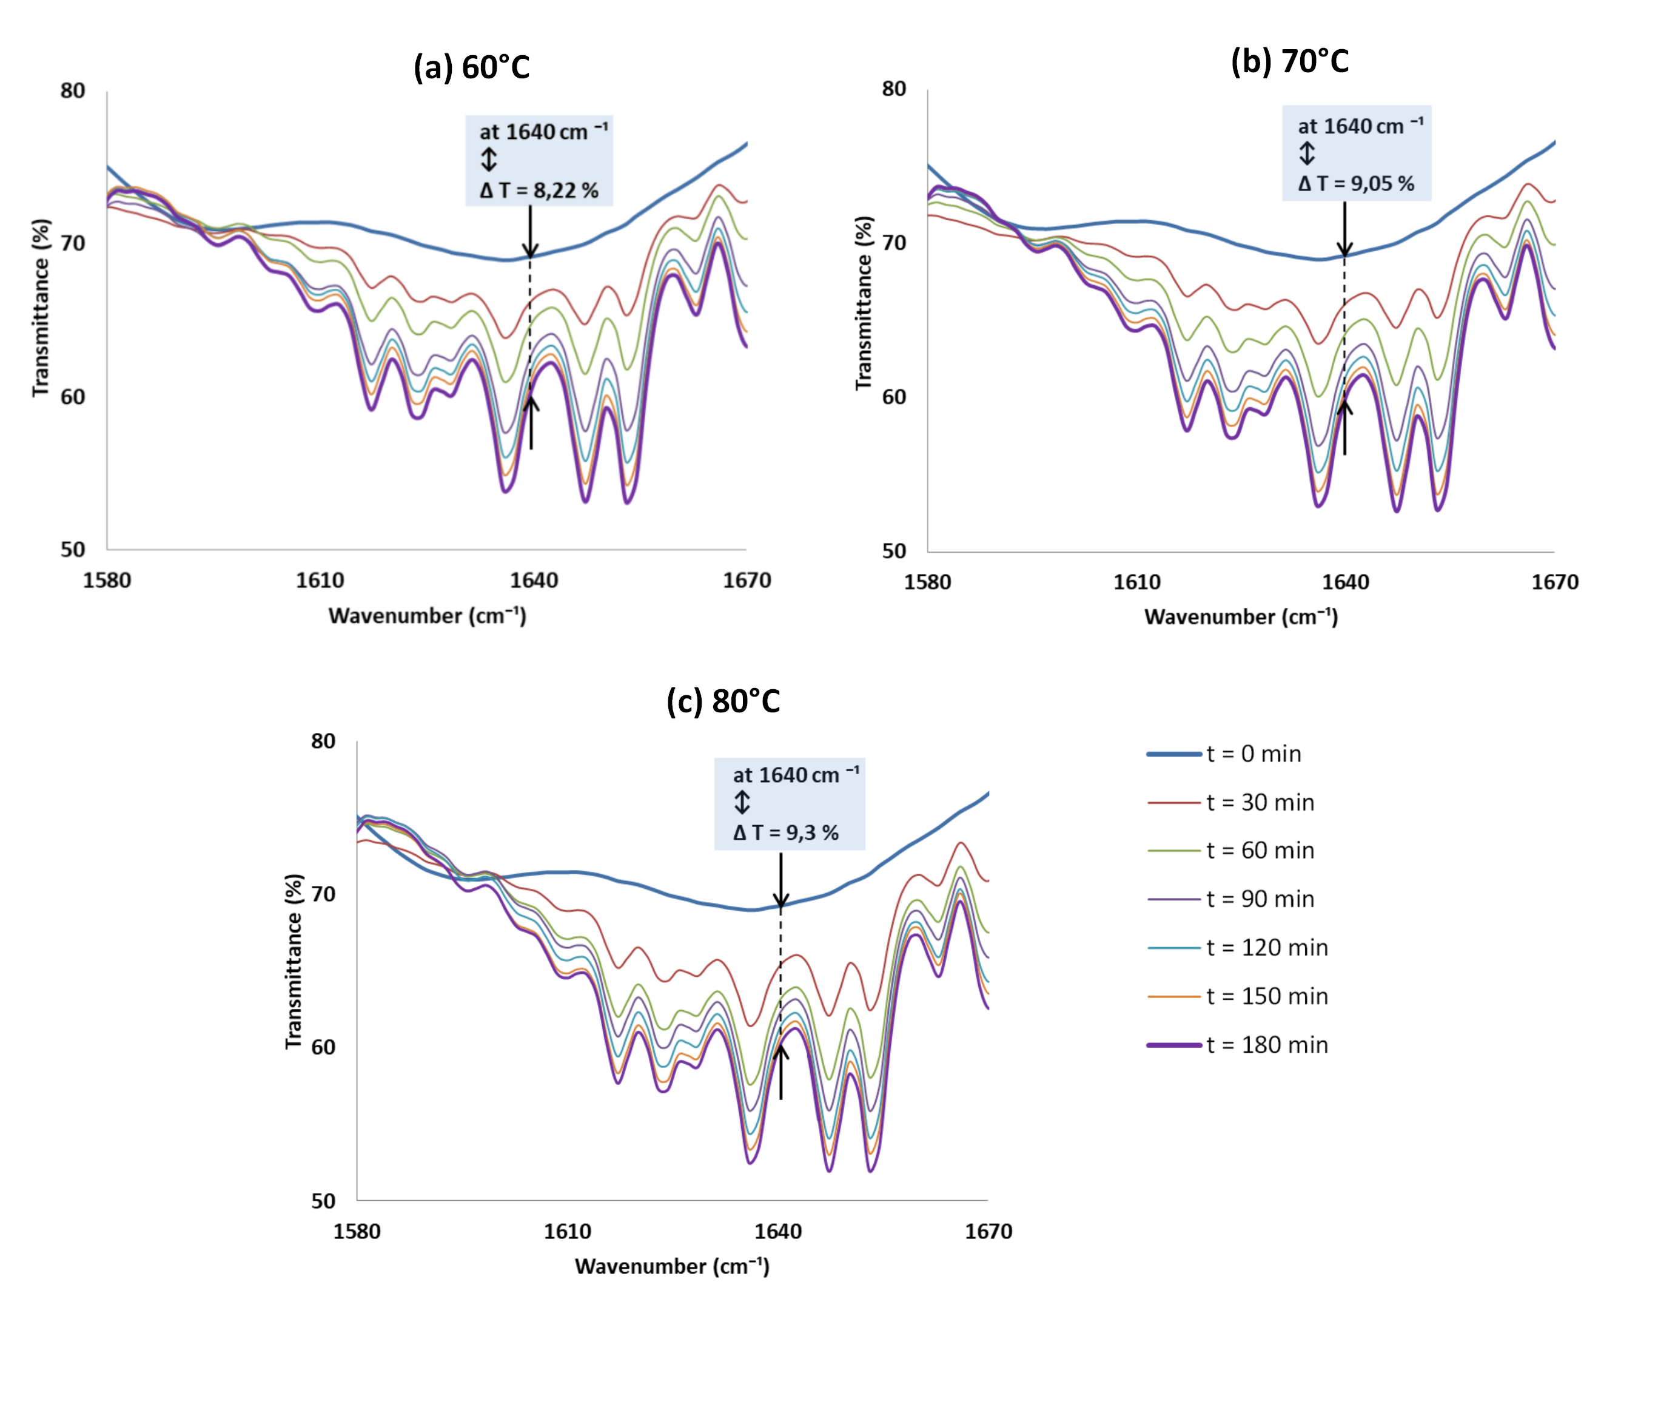
Figure 2: ATR-FTIR spectra in the 1580–1670 cm⁻¹ range: (a) 60°C, (b) 70°C, and (c) 80°C showing the time-dependent changes in the reaction.
Figure 2 shows the time-dependent changes in the ATR-FTIR spectra in the 1580–1670 cm⁻¹ range at 60, 70, and 80°C. At all temperatures, the transmittance values in this region consistently changed over time. In particular, the signal around 1640 cm⁻¹ was chosen as a convenient representative point for comparing spectral changes at different temperatures. The transmittance differences at this point were ΔT = 8.22% at 60°C, ΔT = 9.05% at 70°C, and ΔT = 9.30% at 80°C. The increasing ΔT values indicate that spectral changes intensified with rising temperature. Although the largest ΔT value was observed at 80°C, the similarity between the values at 70 and 80°C suggests that the spectral change amplitude does not sharply increase at higher temperatures. This behavior may be related to the decreasing temperature sensitivity of the reaction after a certain threshold or the presence of additional limiting factors within the system.
Conversion values for each time point were calculated based on the spectral parameters obtained from the ATR-FTIR spectra in the 1580–1670 cm⁻¹ range. This approach allowed for quantitative evaluation of the reaction progress and comparison of the process dynamics at different temperatures. The time dependence of conversion was analyzed to compare the reaction rate and final conversion levels at different temperatures.
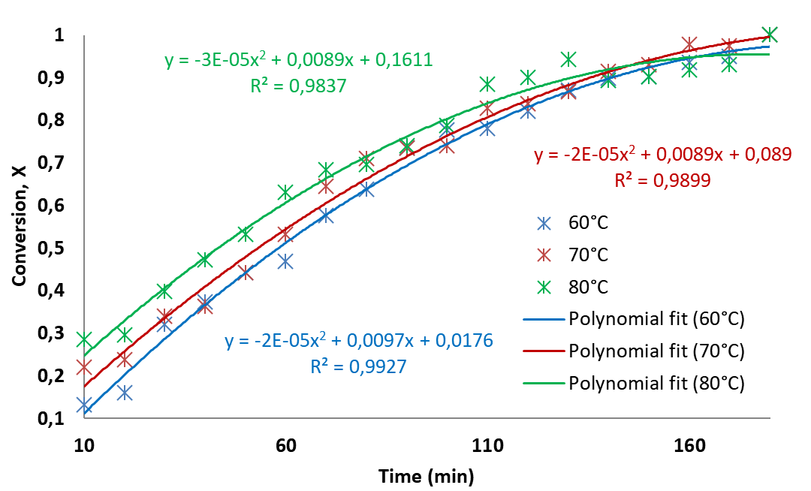
Figure 3: Time dependence of reaction conversion at 60, 70, and 80°C
As shown in Figure 3, at all temperatures, conversion increases over time. In the initial phase, particularly between 10 and 80 minutes, conversion increased rapidly. In the subsequent time intervals, the slope of the curves decreased, and the process gradually approached a plateau, i.e., the final stage of the reaction. A second-degree polynomial fit was applied to visually describe the experimental points. Kinetic parameters were determined using the apparent first-order kinetic model described above. At 80°C, the conversion shows the highest values in the initial stages, indicating that the reaction proceeds faster at higher temperatures. The curve at 70°C is positioned higher than at 60°C, representing an intermediate kinetic state. Additionally, the curves at 70 and 80°C tend to converge in the final stages, suggesting that the acceleration of the reaction at higher temperatures may be somewhat limited. Polynomial fit lines were used to describe the overall trend of the experimental points. The correlation coefficients for 60, 70, and 80°C were 0.9927, 0.9899, and 0.9837, respectively. These fitting results were used only to visualize the conversion profiles, whereas the kinetic parameters were determined using the apparent first-order kinetic model described above.
To evaluate the overall kinetic behavior of the reaction, the conversion values obtained from the ATR-FTIR spectra were analyzed using an apparent first-order kinetic model. Although the reaction between morpholine and sodium monochloroacetate formally proceeds through an SN2 mechanism, the objective of the present kinetic treatment was not to establish the intrinsic elementary reaction mechanism but to describe the overall reaction progress under the investigated experimental conditions. Therefore, the conversion values obtained at each temperature were analyzed according to the apparent first-order equation, ln(1−X)=−kt. If the selected kinetic model adequately describes the reaction, a linear relationship between ln(1−X) and time is expected. The slopes of the linear regression lines were taken as the apparent reaction rate constants.
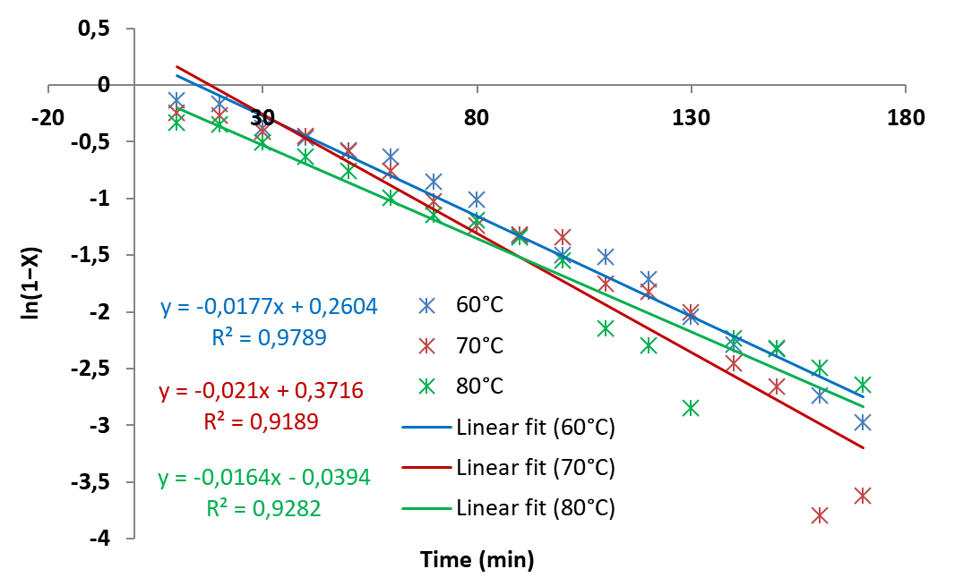
Figure 4: Time dependence of ln(1−X) at 60, 70, and 80°C and linear fit lines.
Figure 4 shows the time dependence of ln(1−X). At all temperatures, a nearly linear relationship between ln(1−X) and time was observed, indicating that the apparent first-order kinetic model provides a satisfactory description of the experimental data under the investigated conditions. The rate constants were determined from the linear regression equations. At 60°C, k = 0.01653 min⁻¹, at 70°C, k = 0.01729 min⁻¹, and at 80°C, k = 0.01752 min⁻¹. The rate constant increased from 0.01653 min⁻¹ to 0.01752 min⁻¹ with the temperature rise, but the difference between the values was not significant. These results indicate a weak temperature dependence of the reaction rate within the studied temperature range. Additionally, deviations from the regression line were observed at higher temperatures for some points. This phenomenon may be associated with diffusion limitations at higher conversion levels, reduced mixing efficiency, or other transport-related effects; however, additional investigations would be required to confirm their individual contributions. The kinetic parameters determined based on the linear regression results and the values required for Arrhenius analysis are summarized in Table 1.
Table 1: Key kinetic parameter values for the reaction between morpholine and sodium monochloroacetate at different temperatures.
t,°C | T, K | ΔT, % | k, min⁻¹ | R² | 1/T, K⁻¹ | ln(k)
60 | 333 | 8.22 | 0.01653 | 0.9809 | 0.003003 | -4.10258
70 | 343 | 9.05 | 0.01729 | 0.9699 | 0.002915 | -4.05763
80 | 353 | 9.30 | 0.01752 | 0.9200 | 0.002833 | -4.04441
As summarized in Table 1, only a modest increase in the apparent rate constants was observed over the investigated temperature range. Together with the lower R² value obtained at 80°C, this suggests that the reaction may gradually deviate from ideal apparent first-order behavior at higher temperatures. To further examine the temperature dependence of the reaction, the Arrhenius relationship between ln(k) and 1/T was analyzed, allowing the apparent activation energy to be estimated from the slope of the linear regression.
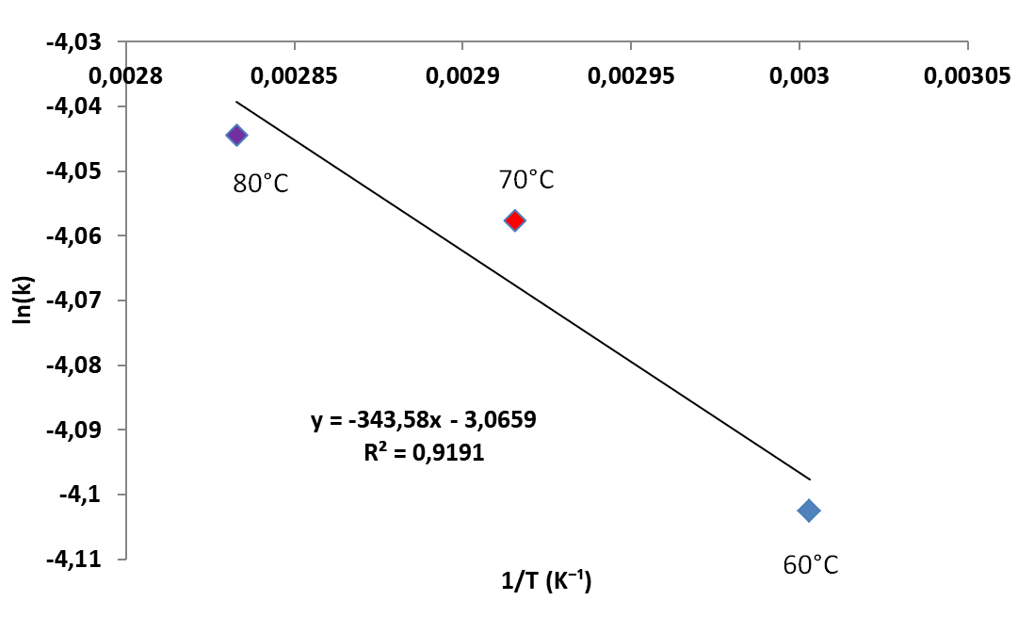
Figure 5: Arrhenius plot of ln(k) versus 1/T
Figure 5 presents the Arrhenius plot obtained from the relationship between ln(k) and 1/T. A satisfactory linear correlation between ln(k) and 1/T was observed, indicating that the apparent reaction rate follows the Arrhenius trend within the investigated temperature range. The linear regression yielded the equation y = −343.58x − 3.0659, from which an apparent activation energy of 2.86 kJ/mol was calculated. This value is relatively low for the investigated reaction system and should therefore be interpreted with caution. First, the Arrhenius analysis was performed using only three experimental temperature points within a relatively narrow temperature interval (60–80°C), which limits the sensitivity of the calculated slope. Second, the ATR-FTIR monitoring results indicated that the conversion increased rapidly during the initial stage of the reaction, whereas after approximately 90–100 min only minor spectral changes were observed as the system gradually approached a plateau. Consequently, the apparent rate constants were derived from an overall kinetic response that included both the chemically active stage and the later stage characterized by much slower spectral changes. In addition, possible contributions from diffusion, mass-transfer, and mixing effects during the later stages of the reaction cannot be excluded. Therefore, the calculated activation energy should be regarded as an apparent kinetic parameter describing the overall process under the selected experimental conditions rather than the intrinsic activation barrier of the elementary SN2 reaction. The correlation coefficient (R² = 0.9191) supports an acceptable Arrhenius fit while also reflecting the inherent variability associated with the limited experimental dataset.
  - Conclusion
In this study, ATR-FTIR spectroscopy was successfully applied for real-time monitoring of the reaction between morpholine and sodium monochloroacetate and for evaluating its kinetic behavior under different temperature conditions. The apparent first-order kinetic model provided a satisfactory description of the experimental data, enabling the determination of the apparent reaction rate constants and the apparent activation energy. Although the reaction rate increased with temperature, only modest differences in the kinetic parameters were observed within the investigated temperature range. The relatively low apparent activation energy and the gradual approach to a plateau at the later stages of the reaction suggest that the overall kinetic behavior may be influenced by additional physical factors, such as diffusion or mass-transfer effects, under the selected experimental conditions. Overall, the proposed ATR-FTIR approach provides a simple, rapid, and reliable tool for real-time kinetic evaluation of the morpholine–sodium monochloroacetate reaction.
Nomenclature
T – absolute temperature, K
t – reaction time, min
X – conversion degree, –
k – reaction rate constant, min⁻¹
Ea – apparent activation energy, kJ/mol
ΔT – change in transmittance, %
R² – correlation coefficient, –
1/T – reciprocal temperature, K⁻¹
ln(k) – natural logarithm of rate constant, –
ν – wavenumber, cm⁻¹
References
Christie L., Rutherford S., Palmer D.S., Baker M.J., Butler H.J., 2024, Bioprocess monitoring applications of an innovative ATR-FTIR spectroscopy platform, Frontiers in Bioengineering and Biotechnology, 12, 1349473.
Dubé M.A., Zheng S., McLean D.D., Kates M., 2004, A comparison of attenuated total reflectance-FTIR spectroscopy and GPC for monitoring biodiesel production, Journal of the American Oil Chemists’ Society, 81, 599–603.
Elangovan S., Neumann J., Sortais J.-B., Junge K., Darcel C., Beller M., 2016, Efficient and selective N-alkylation of amines with alcohols catalysed by manganese pincer complexes, Nature Communications, 7, 12641.
Hamlin T.A., Swart M., Bickelhaupt F.M., 2018, Nucleophilic substitution (SN2): Dependence on nucleophile, leaving group, central atom, substituents, and solvent, ChemPhysChem, 19, 1315–1330.
Husar J., Ait El Maati M., 2025, Real-time FTIR-ATR monitoring of transesterification: A convenient method for kinetic studies, International Journal of Molecular Sciences, 26, 9381.
Husár J., Pecha J., Šánek L., 2021, Development and validation of a simple and reliable alternative method for process monitoring and final product quality control during fatty acid ethyl esters production, Talanta, 235, 122752.
Ivanov S.A., Banaru A.M., Kireev V.E., Charkin D.O., Kompanchenko A.A., Gosteva A.N., Aksenov S.M., 2025, Synthesis, crystal structure and spectroscopic study of lead monochloroacetate, Crystallography Reports, 70, 477–485.
Mamatkulova S.O., Maksumova O.S., 2026, Kinetic investigation of the SN2 reaction between piperidine and chloroacetic acid using ATR-FTIR spectroscopy, Chemistry and Chemical Engineering, 2026, 1, Article 8.
Phan T.B., Nolte C., Kobayashi S., Ofial A.R., Mayr H., 2009, Can one predict changes from SN1 to SN2 mechanisms?, Journal of the American Chemical Society, 131, 11392–11401.
Smith M.B., 2020, March’s Advanced Organic Chemistry: Reactions, Mechanisms, and Structure, 8th ed., Wiley, Hoboken, USA.
Tang C., Song X., Qian S., Xiang S., Shen F., Sun L., 2024, Massive acceleration of SN2 reactions using oriented external electric fields, Chemical Science, 15, 12471–12479.
Trevisan M.G., Garcia C.M., Schuchardt U., Poppi R.J., 2008, Evolving factor analysis-based method for correcting monitoring delay in different batch runs for use with PLS: On-line monitoring of a transesterification reaction by ATR-FTIR, Talanta, 74, 971–976.

